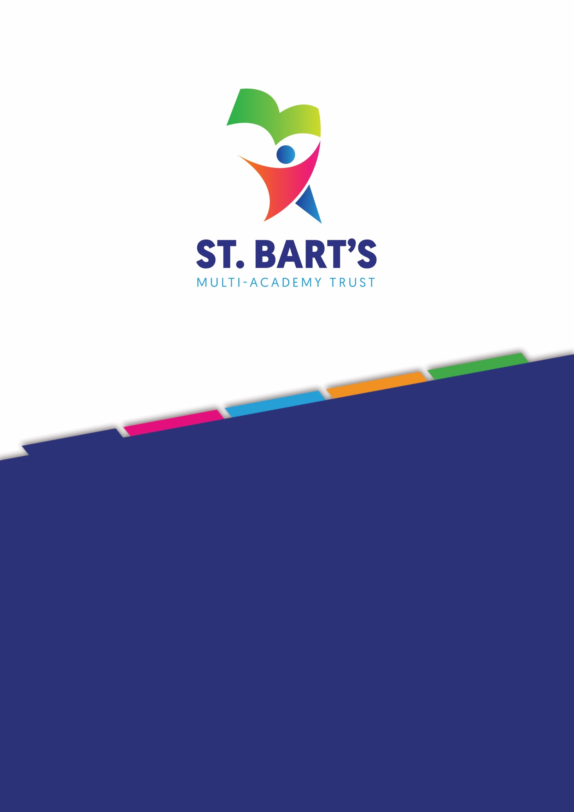
1 | P a g e

SCHOOL UNIFORM POLICY
June 2026

Details

Title: School Uniform Policy
Issued: June 2026 Next Review: June 2027 Owner: Ricky Porter
Category: Operational

Date | Section Amended | Signature
05/03/2026 | Added Section 9 – Nails - Primary Pupils | S. Jones
21/05/2026 | Updated legislation;  Updated policy to reflect Children’s Wellbeing and Schools Act 2026;  Added statement about branded items limit becoming statutory;  Removed ‘school colours’;  Replaced ‘fax’ with ‘email’ for supplier;  Added a section to state how parents can access second-hand uniforms;  Updated table headings | R Porter

Contents
St. Bart’s Mission 4
St. Bart’s Vision and Values 4
School Uniform Policy 5
Statement of intent 5
- Legal framework 5
- Roles and responsibilities 6
- Cost principles 7
- Equality principles 8
  - Gender 8
  - Religion and belief 9
  - Race 9
  - SEND and medical conditions 9
- Complaints and challenges 10
- School uniform supplier 10
- Uniform assistance 10
- Non-compliance 11
- School uniform 11
  - Clothing 11
  - Jewellery 11
  - School bag 11
  - Hairstyles 12
  - Makeup 12
  - Nails 12
  - College Uniform (Abbey Hill only) 12
- Adverse weather 12
- Labelling 13
- Monitoring and review 13
Appendix 1 – School Uniform Academy Information 14
Appendix 2 – School Uniform Assistance Application Form 15


Flourishing Together Releasing Potential Inspiring Futures
and have it to the full.”

St. Bart’s vision includes a strong commitment to preparing our children for a world impacted by climate change, through learning and practical experience. We encourage pupils and staff to consider the impact of their actions locally and globally, while embedding climate change education across our curriculum, and sustainability into our ethos and Trust-wide practice.
4 | P a g e

St. Bart’s Mission
We ensure that every academy is a flourishing community, dedicated to releasing potential and inspiring ambitious futures through exceptional education.

St. Bart’s Vision and Values
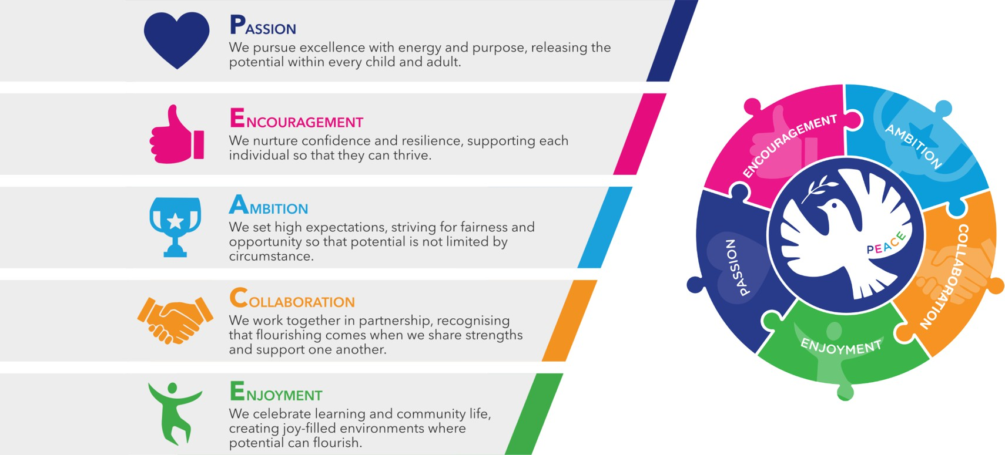
Releasing potential together through PEACE:

Our Trust Christian ethos is captured by the PEACE values and all schools work in close partnership (whether C of E or community) to ensure that all children, adults and the communities they serve flourish just as Jesus encouraged us to do in John 10:10 – “I have come that they may have life,

School Uniform Policy

Statement of intent
St Bart’s Multi-Academy Trust believes that a consistent school uniform policy is vital to promote the ethos of the school and provide a sense of belonging and identity for all pupils, regardless of their protected characteristics or socio-economic circumstances.
For the purposes of this policy, “uniform” includes the following elements of pupils’ appearance:

- Clothing, including the school uniform itself, variations of the school uniform such as PE kits, and other clothing worn at school, e.g. non-uniform
- Hairstyles and headwear
- Jewellery and other accessories
- Cosmetics such as makeup and nail polish

This policy lays out the measures the school has taken to ensure a consistent, fair and inclusive uniform policy, and to implement a uniform that reflects the needs of all pupils, and is affordable and the best value for money for the school and pupils’ families.
We believe that pupils learn most effectively and achieve their best outcomes when they are comfortable, able to be themselves, and dressed in such a way that sets an appropriate tone for education.

Legal framework
This policy has due regard to all relevant legislation and guidance including, but not limited to, the following:
- Human Rights Act 1998
- Education and Inspections Act 2006
- Equality Act 2010
- Education Act 2011
- UK GDPR and Data Protection Act 2018
- Education (Guidance about Costs of School Uniforms) Act 2021
- Children’s Wellbeing and Schools Act (2026)
- DfE (2025) ‘Cost of school uniforms’
- DfE (2021) ‘School Admissions Code’
- DfE (2025) ‘School uniforms’
- Equality and Human Rights Commission (2022) ‘Preventing hair discrimination in schools’

From September 2026, the Children's Wellbeing and Schools Act 2026 will introduce a statutory limit on the number of compulsory branded items of uniform and PE kit that schools can require. Schools must limit compulsory branded items to 3 or fewer. Secondary and middle schools may also have a tie as a 4th compulsory branded item.

Roles and responsibilities
The LGC is responsible for:

- Establishing, in consultation with the Principal and school community, a practical and smart school uniform that accurately reflects the school’s vision and values
- Ensuring that the school’s uniform is accessible and inclusive, and does not disadvantage any pupil by virtue of their protected characteristics or socio-economic status
- Listening to the opinions and wishes of parents, pupils and the wider school community regarding changes to the school’s uniform
- Ensuring that the school’s uniform is accessible and affordable
- Demonstrating how best value for money has been achieved in the uniform policy
- Ensuring compliance with the DfE’s ‘Cost of school uniforms’ guidance and the statutory limit on compulsory branded items from September 2026

The Principal is responsible for:

- Enforcing the school’s uniform on a day-to-day basis.
- Ensuring that teachers understand this policy and what to do if a pupil is in breach of the policy.
- Listening to the opinions and wishes of the school community in regard to the school’s uniform and making appropriate recommendations to the governing board.
- Providing pupils with an exemption letter as appropriate, e.g. for a pupil who has a broken arm and requires a loose-fitting top.
- Processing and approving all eligible School Uniform Assistance Application Forms

Staff members are responsible for:

- Ensuring that pupils dress in accordance with this policy at all times
- Ensuring that pupils understand why having a consistent and practical school uniform is important eg: school identity

Parents are responsible for:

- Providing their children with the correct school uniform as detailed in this policy
- Informing the Principal if their child requires a more relaxed uniform policy for a period of time, including why
- Ensuring that their child’s uniform is clean, presentable and the correct size

Pupils are responsible for:

- Wearing the correct uniform at all times, unless the Principal has granted an exemption
- Looking after their uniform as appropriate
- Understanding and respecting why a school uniform is important to the school eg: school identity and community

Cost principles
The school is committed to ensuring that its school uniform is affordable and accessible to all pupils, and does not place an unreasonable financial burden on parents.
In accordance with the ‘School Admissions Code’, the Principal will ensure that the school’s uniform policy does not discourage parents from applying for a place for their child.
The school will assess the overall cost implications of its uniform policy regularly, including prior to making any changes to the school uniform. When evaluating whether costs are reasonable and proportionate, the school will take into account the opinions and situations of:
- Economically disadvantaged parents
- Parents with multiple children who are, or will be in the future, pupils at the school
- Parents of younger children, as they are likely to grow quickly and require new sets of uniform more frequently
- Parents of pupils with protected characteristics that may impact their ability to access the uniform due to costs
- LAC and PLAC

The school will evaluate the cost of its uniform based on the overall collection of uniform items that parents would need to purchase for a pupil, rather than on the cost effectiveness of individual items; this will include consideration of the fact that parents will need to purchase multiples of certain items eg: shirts and socks, to ensure their child can come to school in clean uniform every day.
The school keeps variations in school uniform for different groups of pupils, e.g. year group-specific items or house colours, to a minimum where possible to ensure that pupils can get the most wear out of their uniform possible and that parents can pass some items down to younger siblings.
From September 2026, the school will limit the number of compulsory branded items of uniform and PE kit to 3 or fewer, in line with statutory requirements.
The school keeps branded uniform items to a minimal level that is reasonable for all members of the school community. The school defines a branded uniform item as any item of clothing that cannot be purchased at a range of retailers, e.g. supermarkets, due to the item’s logo, colour, design, fabric or other unique element.
Where the school requires an item of branded clothing, it will assess how prices can be kept as low as possible and put measures in place to facilitate this. This may include:

- Offering sew- or iron-on logo patches for blazers and jumpers that can be bought at non-specialist retailers, instead of requiring specific branded jumpers.
- Ensuring branded items are longer-lasting and unlikely to be grown out of quickly eg: ties
- Making donated second-hand uniform available for purchase at a lower price

The school is committed to meeting the DfE’s recommendations on costs and value for money. Every care is taken to ensure that our uniforms are affordable for all current and prospective pupils, and that the best value for money is secured through reputable suppliers.
The school works with multiple suppliers to obtain the best value for money possible. Any savings negotiated are passed to parents where possible and does not enter into exclusive single supplier contracts or cash-back arrangements. More information on supplier processes can be found in the ‘School uniform supplier’ section of this policy.
The school will not amend uniform requirements regularly and will take the views of parents and pupils into account when considering any changes to school uniforms.

Equality principles
The school takes its legal obligation to avoid unlawfully discriminating against any protected characteristic very seriously. In line with this, the school will aim to ensure that its uniform policy is as inclusive as possible so that all pupils can access a school uniform which is comfortable, suitable for their needs, and reflects who they are, while avoiding any direct or indirect discrimination on the basis of protected characteristics or socio-economic status.
The school will ensure that parents and pupils are consulted over any changes to school uniform, and that views and advice are sought specifically from pupils, and parents of pupils, who:
- Are transgender, including non-binary pupils
- Have SEND and/or sensory needs
- Are of a religious or cultural background that has dress requirements

Parents’ concerns and requests regarding school uniform and amendments to it are handled on a case-by-case basis by the Principal and Local Governing Committee, and always in accordance with the Trust Complaints Procedure.
Information on how the school ensures its uniform policy does not discriminate against pupils with specific protected characteristics is outlined below.

Gender
To avoid disproportionately impacting pupils of a certain gender, the school will ensure that the cost of uniform is as equal in price as possible across items for all genders.
This includes:

    - Adhering to the procedures laid out in the ‘Cost principles’ section of this policy
    - Not directly requiring pupils of a certain gender to buy additional uniform eg: by requiring female pupils to buy both trousers and skirts
    - Not indirectly requiring pupils of a certain gender to buy additional uniform eg by offering football in PE to only male pupils and requiring they buy football boots to participate
    - Not holding pupils of different genders to different uniform standards eg: by banning certain hairstyles for only one gender

The school will implement a gender-neutral uniform, meaning that pupils will not be required to wear specific items based on their gender, and may wear any of the uniform items listed in the ‘School uniform’ section of this policy regardless of the legal sex recorded on the school’s records. Transgender pupils are supported to access the uniform that best reflects their gender expression.

Religion and belief
To avoid disproportionately impacting pupils of a certain religion, belief or culture, the school will ensure that there is flexibility to allow pupils to present themselves in a way that adheres to their dress requirements as far as possible, within the school’s uniform policy.
The school will endeavour to meet all requests for amendments to the uniform for these purposes; however, the needs and rights of individual pupils will be weighed against any health and safety concerns appropriate to the circumstances eg: if safety headgear needs to be worn.

Race
To avoid disproportionately impacting pupils of a certain race, the school will ensure that its uniform policy does not constitute unlawful indirect discrimination through blanket rules. This includes:
    - Not banning hairstyles related to a pupil’s ethnic origin eg: natural Afro hairstyles
    - Not banning hairstyles worn because of cultural, family and social customs eg: cornrows
    - Not banning head coverings related to a pupil’s culture or ethnic origin eg: African heritage head wraps

The school will follow the good practice guidance provided by the Equality and Human Rights Commission on ‘Preventing hair discrimination in schools’.

SEND and medical conditions
To avoid disproportionately impacting pupils with SEND or medical conditions, the school will ensure its uniform policy takes into account the needs of these pupils. This includes:
    - Ensuring the school uniform uses soft, stretchy fabrics and avoids intricate buttons or hard seams

    - Allowing variations to the standard uniform for pupils whose medical conditions may impact how they dress eg: pupils with casts who require loose-fitting clothing or pupils with hair loss-related conditions who wish to wear head coverings

Where the needs of these pupils cannot be met in the standard uniform policy, individual adaptations to the uniform will be considered and permitted wherever possible.

Complaints and challenges
The school endeavours to resolve all uniform complaints and challenges locally and informally, in accordance with the Trust Complaints Procedure.
To make a complaint, parents should refer to the Complaints Procedure and follow the procedures outlined.
When a complaint is received, the school works with parents to arrive at a mutually acceptable outcome.
Governors are willing to consider reasonable requests for flexibility to allow a pupil to accommodate particular social and cultural circumstances.

School uniform supplier

For Academy specific information please see completed Appendix 1.

The Local Governing Committee (LGC) will ensure that a written contract is in place with the supplier for branded items.
The school will retender the uniform contract every five years, whether changes to the uniform are made or not, in line with the Trust’s procurement procedures. The LGC will be able to demonstrate how uniform is procured at the best value for money. The Principal will work to ensure that the items are procured as cheaply as possible without compromising on the quality eg: by requesting standard-style items from the supplier rather than more intricate and unique designs.
The school does not sign contracts with suppliers before requesting visualisations of proposed uniform, as well as fabric samples.
Where the school is proposing to change suppliers, it will reach out to suppliers by October in the determination year.

Uniform assistance

For Academy specific information please see completed Appendix 1.

The school supports vulnerable families in meeting the costs of uniforms. School uniform assistance is provided via a voucher that can be spent on school clothing. The budget for the school uniform assistance scheme will be derived from Pupil Premium funds.

To claim school uniform assistance, pupils should be eligible for Free School Meals (FSM). Eligibility is determined by checking original documents from the relevant authority, detailing receipt of the benefit and the address of the pupil.
Families who meet the criteria should complete the School Uniform Assistance Application Form
and return it to the school office.

The school holds second-hand school uniforms for parents to access. Parents are invited to donate their child’s uniform when they no longer need it.

Non-compliance
Staff members are permitted to discipline pupils for breaching this policy, in accordance with the school’s Behaviour Policy. Parents will be notified in all cases.

School uniform

Clothing

For Academy specific information please see completed Appendix 1.

Pupils who are wearing skirts must also wear white socks/black tights.

Trainers are not considered suitable footwear (except for PE). Heeled shoes and boots are not permitted; ankle boots are permitted. Parents are responsible for ensuring their child brings their PE kit to school when needed.

Jewellery
Permitted jewellery that may be worn is:

One pair of stud earrings – no other piercings are permitted

A sensible wristwatch

Jewellery is the responsibility of the pupil and not the school. Lost or damaged items will not be refunded. All jewellery must be removed during practical lessons, including PE lessons and science experiments.

School bag
Where a school bag is required, pupils must use an appropriately sized waterproof bag to carry their books and equipment.
School bags featuring inappropriate images, slogans or phrases are not permitted.

The school encourages pupils to bring non-valuable bags to school. The school will not be liable for lost or damaged school bags.

Hairstyles
The school reserves the right to make a judgement on where pupils’ hairstyles or hair colours are inappropriate for the school environment; however, will ensure that any such judgements do not discriminate against any pupil by virtue of their protected characteristics. Each individual pupil’s scenario will be taken into account where any judgements on appropriateness are to be made, and parents will always have the freedom to complain via the Trust Complaints Procedure.
Pupils with long hair must ensure that this does not impede their vision, cover their face or provide a health and safety risk. Long hair must be tied up during practical lessons eg: during PE.
The following hairstyles are not considered appropriate for school:

Brightly-coloured, dyed hair
    - Lines and patterns shaved into the hair (the school will consider exceptions to rules on patterns and lines where they are related to a pupil’s culture, race, or religion)

Headwear with bold patterns or colours

Excessive hair accessories

Makeup
Make up is not permitted

Nails
For safety, hygiene, and practical learning reasons, pupils should not wear nail varnish, acrylic nails, or stick-on/false nails. This ensures that children’s hands are safe for classroom activities, play, and practical learning, and helps prevent injury to themselves or others.

College Uniform (Abbey Hill only)
The school uniform does not apply to the college students. However, students are expected to dress appropriately.
Please note: we cannot accept liability for clothing, jewellery and other items that are brought into school/college and subsequently go missing.

Adverse weather
All pupils are required to wear weather-appropriate clothing that covers as much of their skin as possible during adverse weather.
For hot temperatures, this includes wearing:

- Loose-fitting and lightweight shirts and dresses with sleeves and collars or covered necklines.
- Knee length skirts, shorts or trousers.

Pupils are advised not to wear any jumpers during heatwaves. If outside during break times, pupils not wearing sun-safe clothing are advised to stay in an area protected from the sun.
For cold temperatures, this includes wearing:

- Scarfs, gloves, coats and hats when they are outside.
- Warm jumpers that conform to the school’s uniform policy.
- Trousers, or thick tights with skirts.

Labelling
All pupils’ clothing should be clearly labelled with their name.

Any lost clothing will be taken to the lost property box in the school office. All lost property will be retained for one week and will be disposed of if it is not collected within this time.

Monitoring and review
This policy is reviewed annually by the Trust Board.

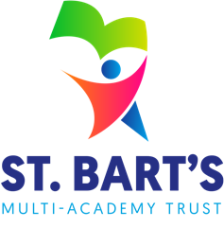
Appendix 1 – School Uniform Academy Information

ST. BART’S MULTI-ACADEMY TRUST
School Uniform Policy
Academy Specific Information

This appendix must be completed by each academy

It should be maintained and reviewed in line with the overarching School Uniform Policy.

Academy: | St John’s CofE Primary Academy

SECTION 7 – SCHOOL UNIFORM SUPPLIER
Our current school uniform supplier is:
Supplier Name: | Smart Uniform
Address: | Harvey House, Hassell Street, Newcastle, ST5 1AR
Telephone Number: | 01782 713650
Email Address: | shop@smartuniform.co.uk
Website: | smartuniform.co.uk
School Uniform Voucher Accepted? | Yes | X | No | ☐

SECTION 8 – UNIFORM ASSISTANCE
School uniform assistance is provided via a voucher worth: |  | £15.00
Second-hand uniform is available via | The school office

SECTION 10 – SCHOOL UNIFORM - CLOTHING
Item | Optional or  Compulsory | Branded / Generic | How to acquire | Cost per item from school supplier
Regular School Uniform - clearly state whether each item is ‘compulsory’ or ‘optional’ and whether each item is ‘branded’ or ‘generic’
Red sweatshirt or cardigan | Compulsory | Branded (logo) | School Supplier | £14.95 - £18.95
School ties (KS2 only) | Compulsory | Branded | School supplier | £5.95
White shirt (KS2) or white polo t-shirt (EYFS and KS1) | Compulsory | Generic | Any retailer
Black or grey trousers, skirt or pinafore | Compulsory | Generic | Any retailer
Gingham summer dress | Optional | Generic | Any retailer
Black school shoes | Compulsory | Generic | Any retailer
PE Kit
Plain white round neck t-shirt | Compulsory | Branded (logo) or plain | School Supplier (logo) or any other shop (plain) | £5.50
Plain black shorts or joggers | Compulsory | Generic | Any retailer
Trainers | Compulsory | Generic | Any retailer
Accessories
School bag | Optional | Generic | Any retailers

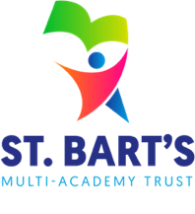
Appendix 2 – School Uniform Assistance Application Form

ST. BART’S MULTI-ACADEMY TRUST
School Uniform
Assistance Application Form

Academy:
Children are eligible for school uniform assistance if they receive Free School Meals.
This scheme is open to children in Years Reception to Year 6. The allowance is for buying suitable school wear and is paid once a year.
PART 1: DETAILS OF PARENT
Your full name:
Title:
National insurance number:
Address:
Postcode:
Phone no.:
Email address:
By supplying us with a phone number or email, you agree to being contacted to let you know if you are eligible.
PART 2: DETAILS OF EACH DEPENDENT CHILD YOU ARE APPLYING FOR
Surname | Other names | Date of birth
Please read this declaration before you sign it
- I declare I am the parent of the child(ren) that I am applying for.
- I declare that all the information I have given is correct and complete to the best of my knowledge.
- I have enclosed original documentation to prove that I am in receipt of one of the benefits listed at the top of this form.
- I am aware that I have a duty to notify the school in writing immediately of any changes in my circumstances which might affect my entitlement to school clothing assistance.
- I understand that information taken from this form will be stored electronically on the school’s computers. The school is permitted to do this under the UK GDPR and Data Protection Act 2018. A copy of the school’s registration is held for inspection.
Signature: |  | Date:

Please return this completed form to the school office.
WHAT HAPPENS NEXT?
If you apply for school uniform assistance and qualify, a voucher will be sent to
you for each of your children during the week of:
If you do not qualify for the payment, we will let you know by letter and phone and explain why.

